**SPRINT-3(APPLICATION BUILDING & DASHBOARD)**

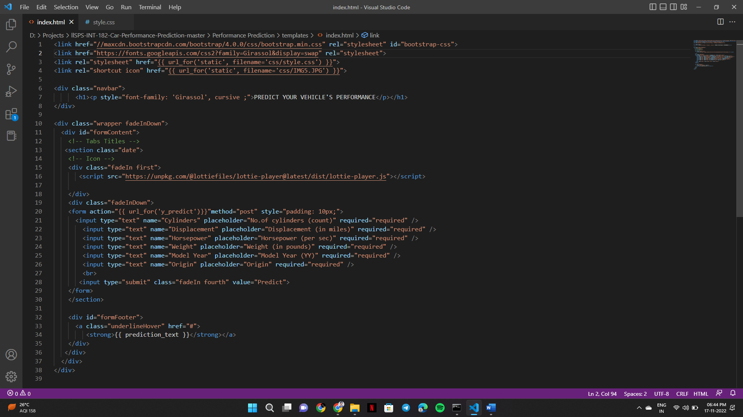**HTML CODE:**

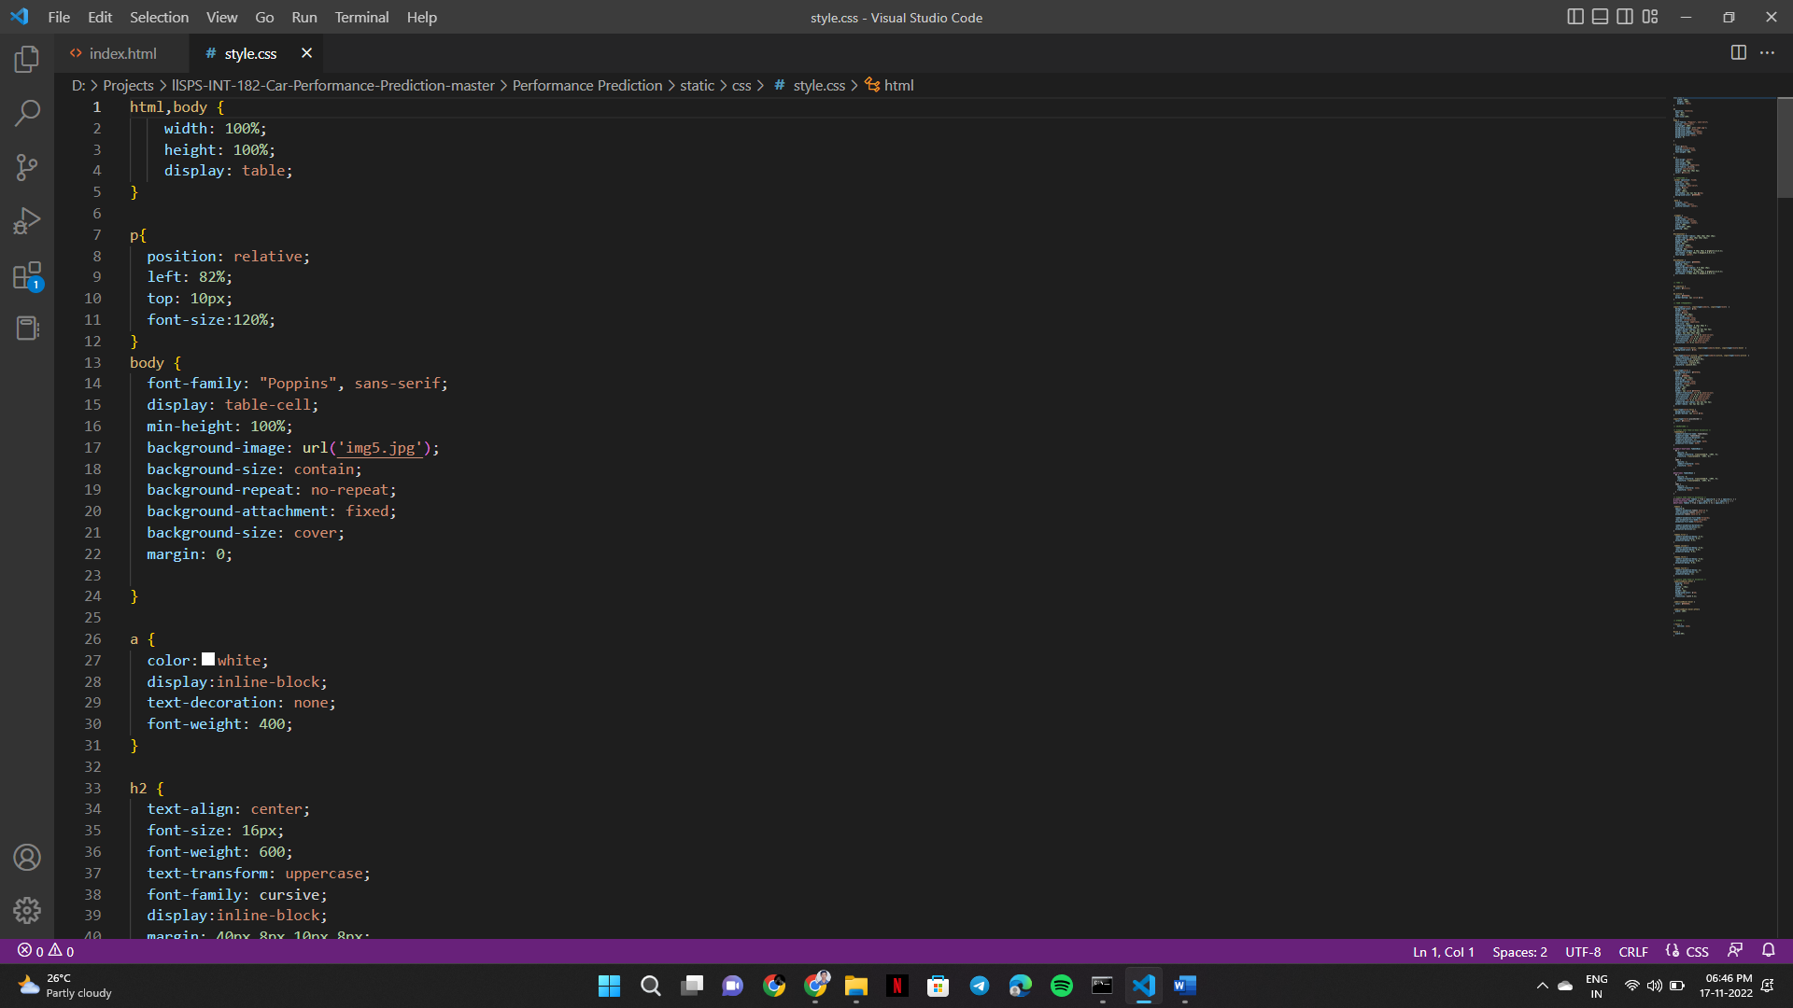**CSS CODE:**

**DASHBOARD:**

**BEFORE PREDICTION:**

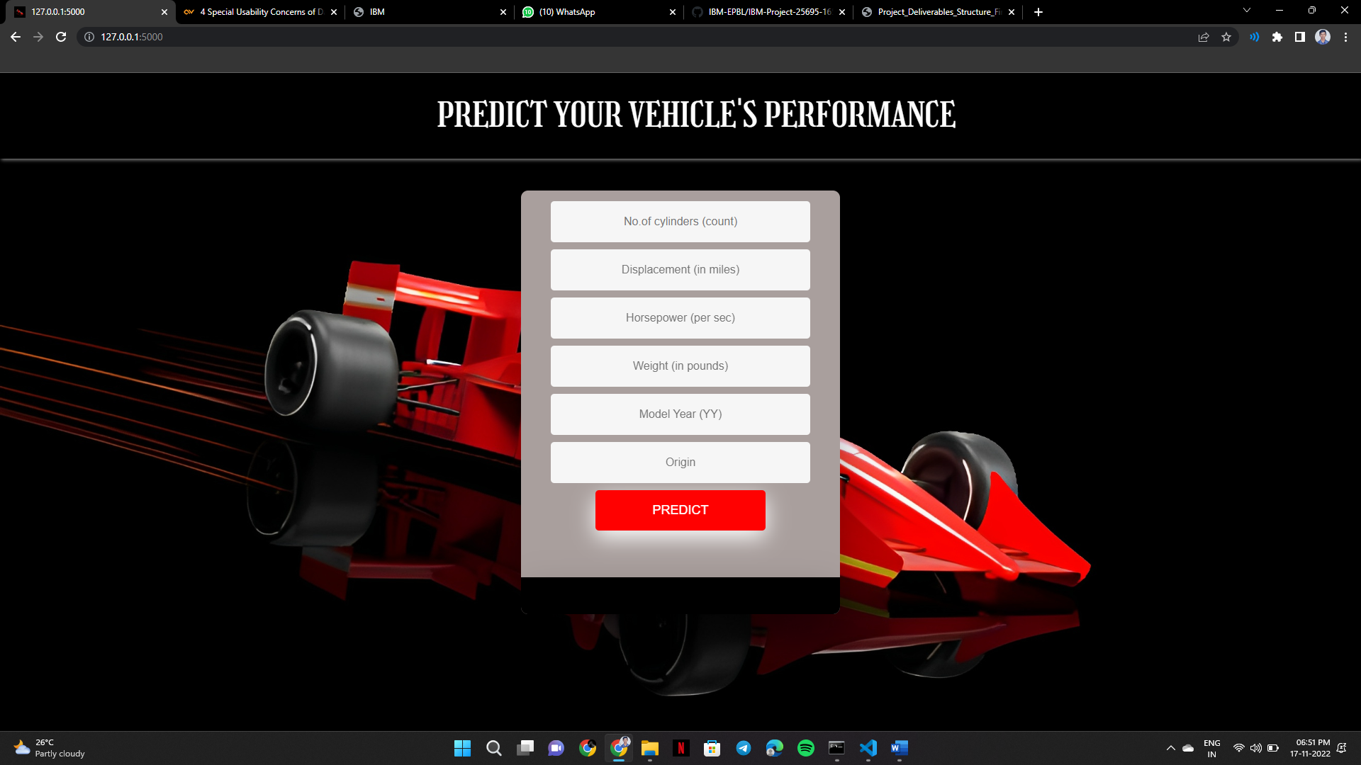

**AFTER PREDICTION:**

